**Project Report**

**on**

**One Stop For All Plants Website**

A Dissertation submitted in partial fulfillment of the academic requirements for the award of the degree.

**Bachelor of Technology**

**In** **Computer Science & Engineering**

Submitted by

S. No. Student Name Roll No

1. **D. Sai Prasanna** 19H51A0567

2. **G. Chinmay Chidwi** 19H51A0568

3. **Gattu Suhasini** 19H51A0569

4. **G. Kiran Deepak** 19H51A0570

Under the esteemed guidance of

**Mr. B. Sivaiah**

Associate Professor



**Department of Computer Science and Engineering**

**CMR College of Engineering & Technology**

(An Autonomous Institution under UGC & JNTUH, Approved by AICTE, Permanently Affiliated to JNTU, Accredited by NBA.)

KANDLAKOYA, MEDCHAL ROAD, HYDERABAD - 501401.

**2019- 2023**

**CMR COLLEGE OF ENGINEERING & TECHNOLOGY**

KANDLAKOYA, MEDCHAL ROAD, HYDERABAD – 501401

**DEPARTMENT OF COMPUTER SCIENCE AND ENGINEERING**



#### 

#### **CERTIFICATE**

This is to certify that the Mini Project-1 report entitled **“One Stop For All Plants (OSFAP)”** being submitted by **D.Sai Prasanna** (19H51A0567)**, G.Chinmay Chidwi** (19H51A0568)**, Gattu Suhasini** (19H51A0569)**, G. Kiran Deepak** (19H51A0570)in partial fulfillment for the award of **Bachelor of Technology in Computer Science and Engineering** is a record of bonafide work carried out his/her under my guidance and supervision.

The results embodied in this project report have not been submitted to any other University or Institute for the award of any Degree.

**B.Sivaiah Dr. K Vijaya Kumar**

**Associate Professor Professor and HOD**

**Dept. of CSE Dept. of CSE**

**TABLE OF CONTENTS**

**CHAPTER NO. TITLE PAGE NO.**

**ABSTRACT**  1

**1** **INTRODUCTION**  2

1.1 Aim of project 2

1.2 Scope of project 2

**2** **BACKGROUND WORK**  3

2.1 Literature survey 3

2.2 Existing models 3

2.3 Drawbacks of existing models 3

**3** **PROPOSED SYSTEM** 4

3.1 Description 4

3.2 Advantages 5

**4** **DESIGNING** 6

4.1 Project architecture 6

4.2 Modules description 7

4.3 UML diagrams 10

**5** **IMPLEMENTATION** 12

5.1 Home Page 12

5.2 Login/Sign up Page 12

5.3 Store and Shopping Cart 14

5.4 Orders and Payment Gateway 15

**6** **RESULTS AND DISCUSSION** 16

**7** **SUMMARY AND CONCLUSION** 17

**8**  **REFERENCES** 18

OSFAP

ABSTRACT

The drastic changes that have taken place across the globe in the past few years have changed the entire lifestyle of human beings. The major part of work is done online. Considering the present changes in the scenario, we decided to design an online plant selling website. The name for this website is OSFAP (One Stop For All Plants). It contains a login page, buyer and seller activities that can be performed, description of each plant, reviews etc.

This website is developed in such a way that both the purchaser’s community and the vendor’s community are benefited. The user can view the plants and its cost without logging into the website. New users should sign up either as a vendor or a customer and omplete the two step authentication and then start shopping.

It has been developed using React for front end, Express.js, Node.js for backend development and MongoDB for database. The website allows different modes of payment and the payment process is safe and secure. It is easy and convenient to use.

CMRCET 1 B.Tech (CSE)

OSFAP

**CHAPTER 1**

INTRODUCTION

1.1 AIM OF THE PROJECT

To create a website that enables users and vendors to purchase and sell plants, i.e. an online nursery. The website must include relevant information about the plants along with reasonable prices and various payment options. It must also allow customers to purchase rare plants and provide necessary reviews.

1.2 SCOPE OF PROJECT

The website will include the basic three web pages that are - home page, login page and registration page. Since it is an e-commerce website, it will contain a shop where the items are displayed and can be added to the cart. After adding the items, there will be a checkout page which will lead to the payment gateway eventually. Each team member is required to take on a task in order to build the website and improve the user interface. We will provide a visually pleasing and user-friendly interface wherein the customers can directly interact with the vendors and provide necessary reviews after delivery.

CMRCET 2 B.Tech (CSE)

OSFAP

**CHAPTER 2**

2.1 LITERATURE SURVEY

We conducted a background research initially to understand the missing features in the existing models. We studied the existing models in detail and gathered necessary information to overcome these issues and provide improved solutions. The outcome of this survey gave us a detailed insight on the software to be used along with the various features to be added.

2.2 EXISTING MODELS

i) [Online Flower Delivery | Send Flowers To India | Best Flower Shop](https://www.floweraura.com/)

ii) [Bloomscape | Home Ready Plants Delivered to Your Door](https://bloomscape.com/)

iii) [Official UrbanStems - Flower & Plant Same Day Delivery](https://urbanstems.com/)

iv) [eBay: Electronics, Cars, Fashion, Collectibles & More](https://www.ebay.com/)

2.3 DRAWBACKS OF EXISTING MODELS

* No direct access and multiple vendors are not supported
* High shipping charges
* Involvement of third party delivery
* No two step authentication
* Non availability of rare plants

CMRCET 3 B.Tech (CSE)

OSFAP

**CHAPTER 3**

PROPOSED SYSTEM

3.1 DETAILED DESCRIPTION

The website URL is mentioned as follows:

<https://osfap-ecom.web.app/>

The website is developed using React, Express.js, Node.js, MongoDB. On clicking the above URL, the user will be redirected to the home page of OSFAP website.Home page shows shop, sign in options. If a user is new to the website and is interested in purchasing plants, they must create a buyer account. If a user wants to sell their plants on OSFAP, they must create a vendor account.

***3.1.1 Features:***

* Signup: New users can create an account easily. While signing up, the user needs to select either buyer or a vendor account based on their interest.
* Easy navigation: The website is convenient to use and easy to navigate.
* Various Collections: The website contains different types of plants that fall under different categories.
* Visual Design: It is visually appealing because the colors used and alignment is done perfectly.
* Typography: The typography used in developing websites is legible, readable and appealing when displayed.
* http protocol: The website is secured with hypertext transfer protocol which means the website is safe to use, protects the website from phishing and date breaching. This builds trust on the website.
* Different payment options: The customer can pay the amount using paytm, gpay, phonepe.

CMRCET 4 B.Tech (CSE)

OSFAP

* Secured payment: The transactions done by the customers through the website are completely safe and secure.
* No third party interaction: The transactions and the orders are only between the vendors and the customers and no other members are involved in it.

***3.1.2 Types of accounts:***

User Account

User account is for the one who is interested in purchasing plants.They can shop on the website. Select the plants they wish to purchase and add them to the cart. After adding to cart, they can pay the amount,enter the address of the delivery and the product gets delivered.

Vendor Account

The users who wish to sell their plants online, OSFAP is the best place for them. They can sign up with the vendor account. They can post the products(plants) they wish to sell on the website. While uploading, the vendor should upload good quality images of the product and details of the product like its cost, uses, description of the product.

3.2 ADVANTAGES

* Supports multiple vendors and provides direct access to vendors
* Includes secured payment methods
* Rare plants are available
* Scientific names are provided for each plant
* Mandatory information fields must be filled by vendor before uploading their plant

CMRCET 5 B.Tech (CSE)

OSFAP

**CHAPTER 4**

DESIGNING

4.1 PROJECT ARCHITECTURE

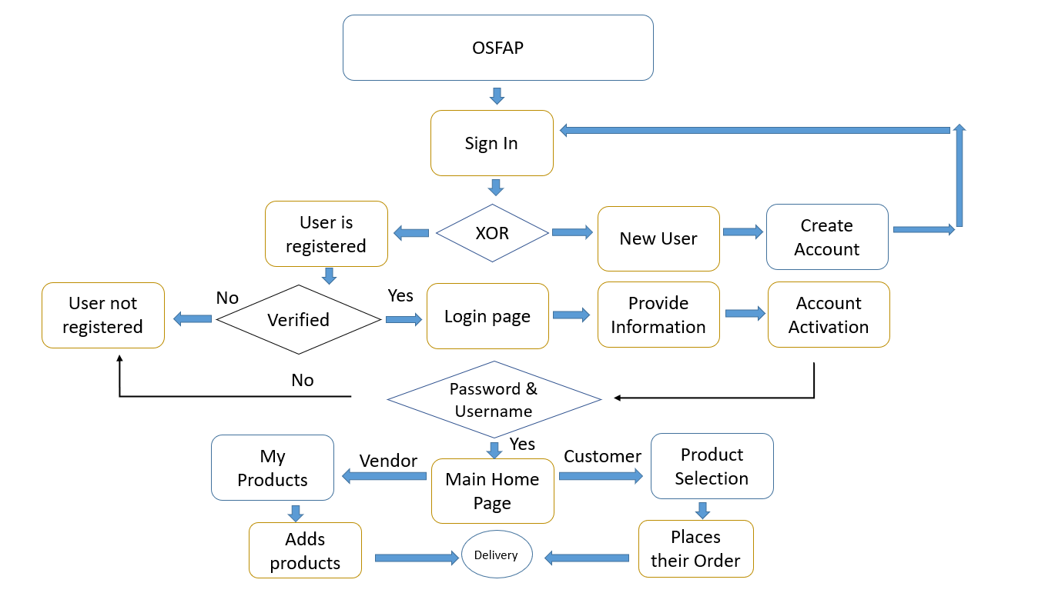

________________________________________________________________

CMRCET 6 B.Tech (CSE)

OSFAP

4.2 MODULES DESCRIPTION

***ReactJS:***



React is the most popular front-end JavaScript library in the field of web development. It is used by large, established companies and newly-minted startups alike (Netflix, Airbnb, Instagram, and the New York Times, to name a few). React brings many advantages to the table, making it a better choice than other frameworks like Angular.js.

* Uses virtual DOM which is a JavaScript object. This will improve apps performance, since JavaScript virtual DOM is faster than the regular DOM.
* Can be used on client and server side as well as with other frameworks.
* Component and data patterns improve readability, which helps to maintain larger apps.

***Node.js:***



Node or more formally *Node.js* is an open-source, cross-platform runtime environment that allows developers to create all kinds of server-side tools and applications in JavaScript. The runtime is intended for use outside of a browser context (i.e. running directly on a computer or server OS). As such, the environment omits browser-specific JavaScript APIs and adds support for more traditional OS APIs including HTTP and file system libraries.

CMRCET 7 B.Tech (CSE)

OSFAP

From a web server development perspective Node has a number of benefits:

* Great performance! Node was designed to optimize throughput and scalability in web applications and is a good solution for many common web-development problems (e.g. real-time web applications).
* Code is written in "plain old JavaScript", which means that less time is spent dealing with "context shift" between languages when you're writing both client-side and server-side code.

***Express.js:***



[Express](https://expressjs.com/) is the most popular *Node* web framework, and is the underlying library for a number of other popular [Node web frameworks](https://expressjs.com/en/resources/frameworks.html). It provides mechanisms to:

* Write handlers for requests with different HTTP verbs at different URL paths (routes).
* Integrate with "view" rendering engines in order to generate responses by inserting data into templates.
* Set common web application settings like the port to use for connecting, and the location of templates that are used for rendering the response.
* Add additional request processing "middleware" at any point within the request handling pipeline.

CMRCET 8 B.Tech (CSE)

OSFAP

***MongoDB:***



MongoDB is a document-oriented NoSQL database used for high volume data storage. Instead of using tables and rows as in the traditional relational databases, MongoDB makes use of collections and documents. Documents consist of key-value pairs which are the basic unit of data in MongoDB. Collections contain sets of documents and functions which is the equivalent of relational database tables. MongoDB is a database which came into light around the mid-2000s.

## MongoDB Features

1. Each database contains collections which in turn contains documents. Each document can be different with a varying number of fields. The size and content of each document can be different from each other.
2. The document structure is more in line with how developers construct their classes and objects in their respective programming languages. Developers will often say that their classes are not rows and columns but have a clear structure with key-value pairs.
3. The rows (or documents as called in MongoDB) don't need to have a schema defined beforehand. Instead, the fields can be created on the fly.
4. The data model available within MongoDB allows you to represent hierarchical relationships, to store arrays, and other more complex structures more easily.
5. Scalability – The MongoDB environments are very scalable. Companies across the world have defined clusters with some of them running 100+ nodes with around millions of documents within the database

CMRCET 9 B.Tech (CSE)

OSFAP

4.3 UML Diagrams

***4.3.1 Use Case Diagram***

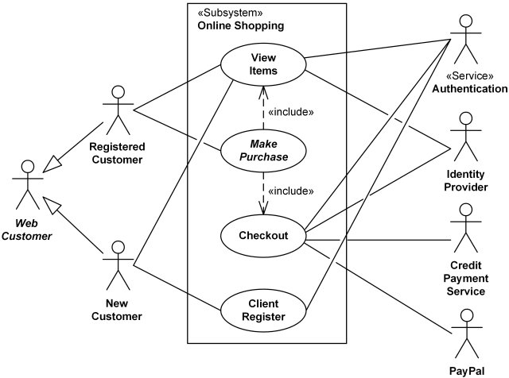

***_________________________________________________________________***

CMRCET 10 B.Tech (CSE)

OSFAP

***4.3.2 Class Diagram***

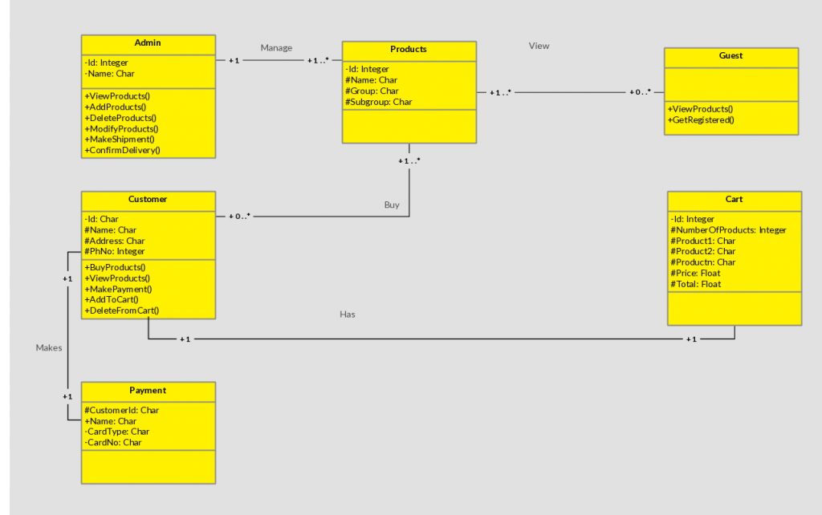

CMRCET 11 B.Tech (CSE)

OSFAP

**CHAPTER 5**

IMPLEMENTATION

5.1 Home Page

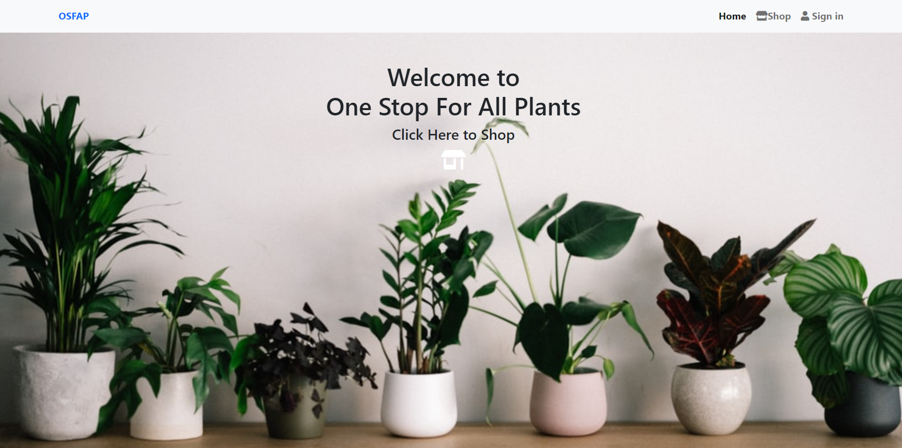

5.2.1 Login Page

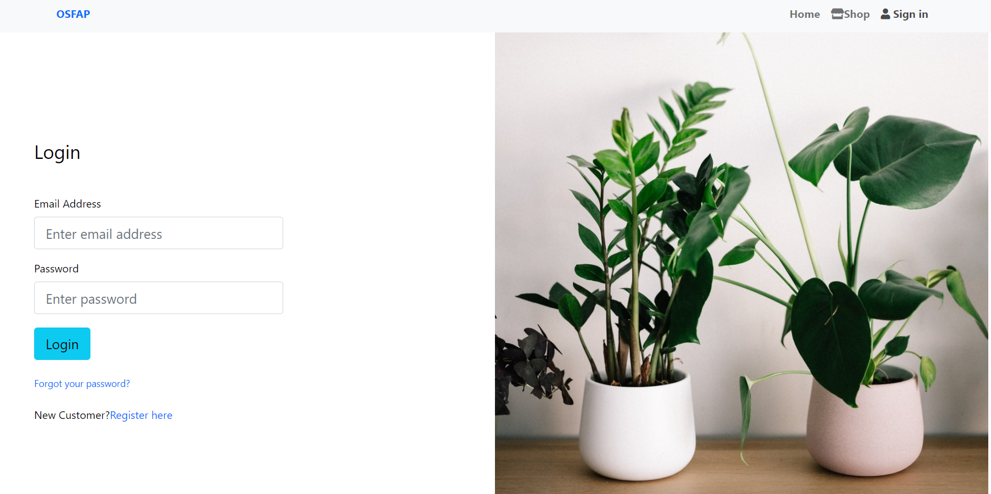

CMRCET 12 B.Tech (CSE)

OSFAP

5.2.2 Signup Page

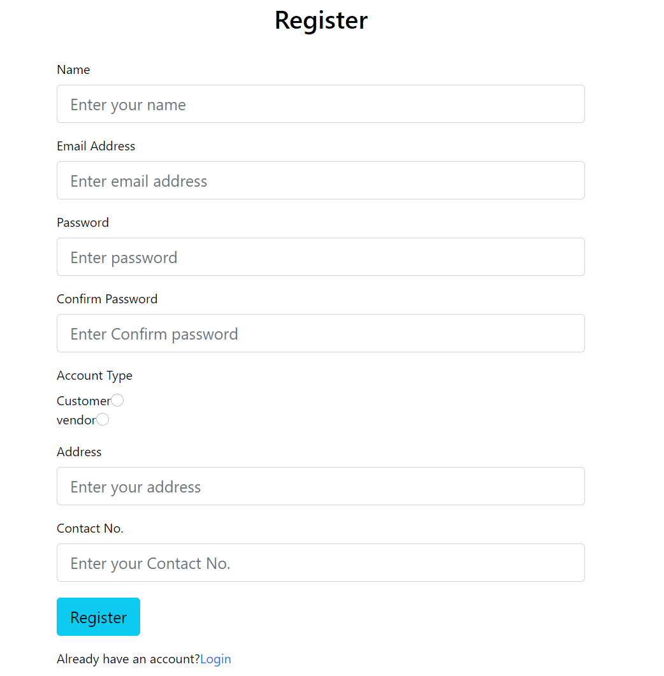

CMRCET 13 B.Tech (CSE)

OSFAP

5.3 Store and Shopping Cart

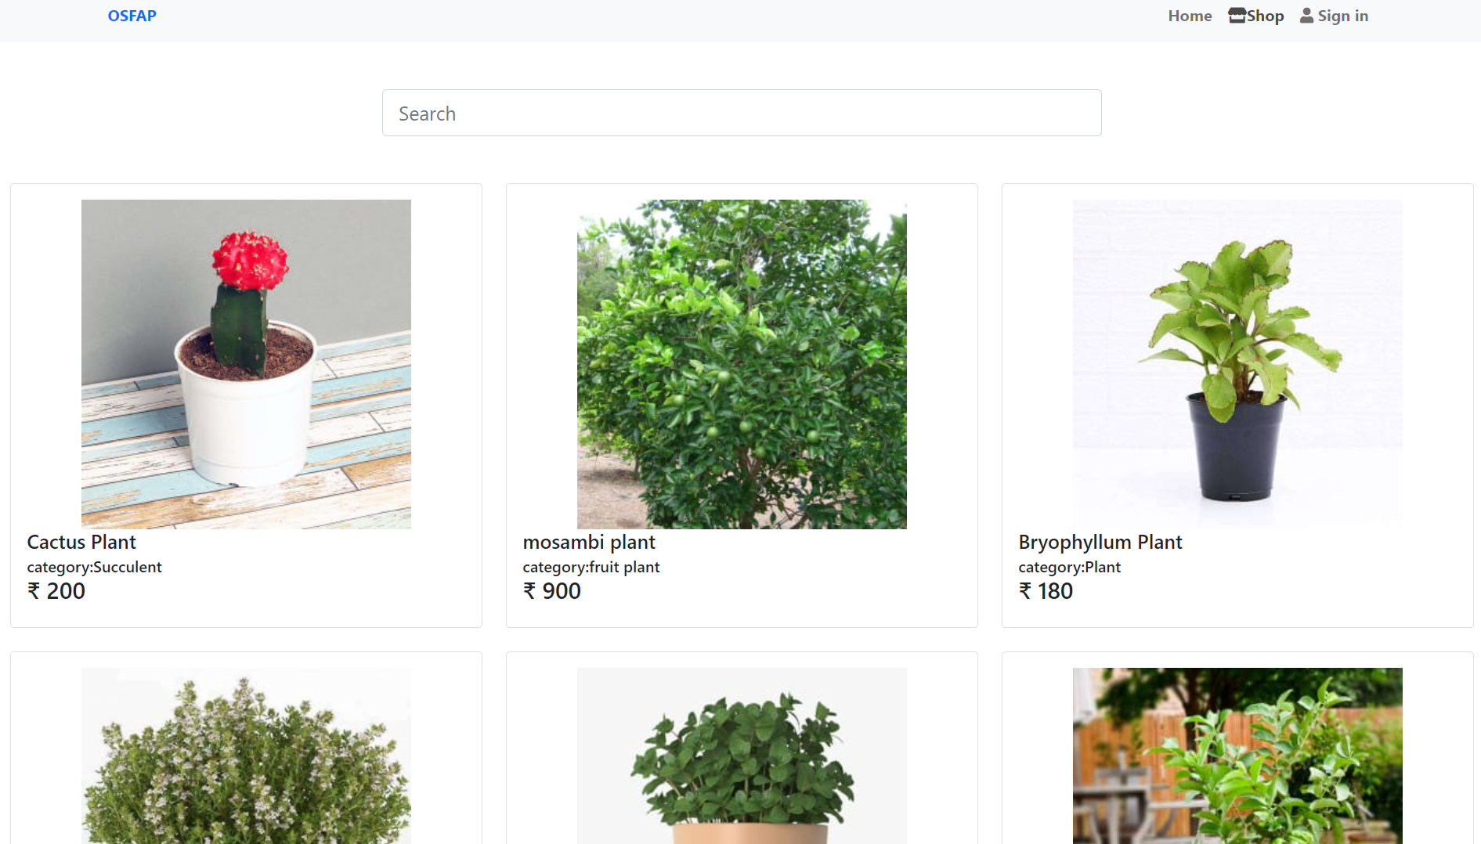

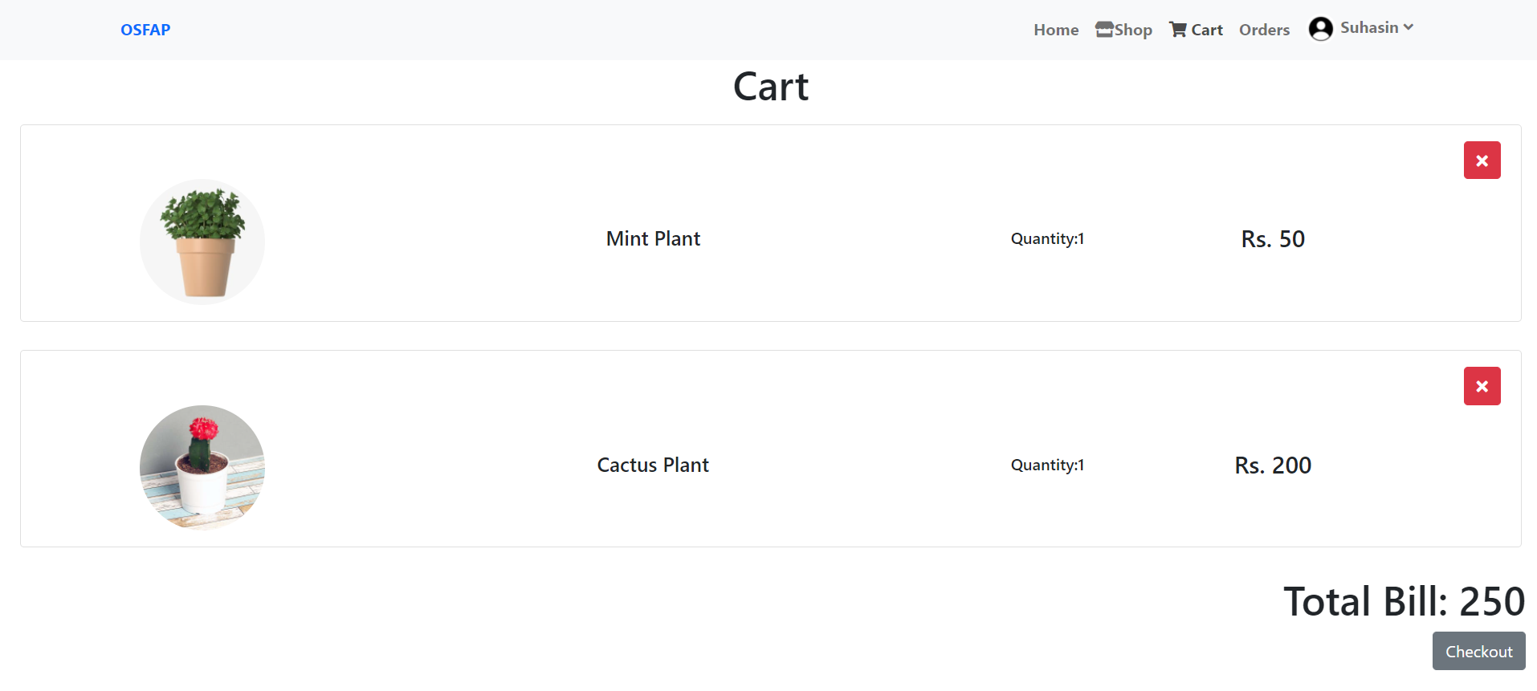

CMRCET 14 B.Tech (CSE)

OSFAP

5.4 Orders and Payment Gateway

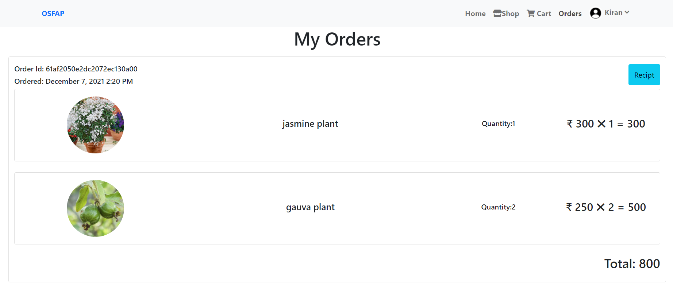

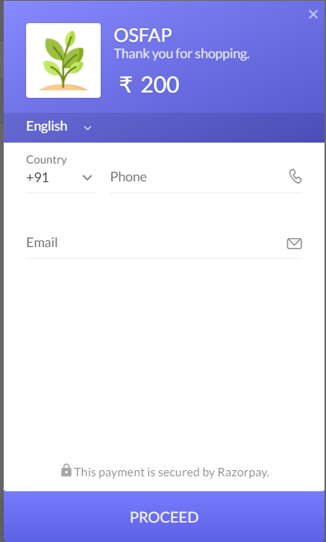 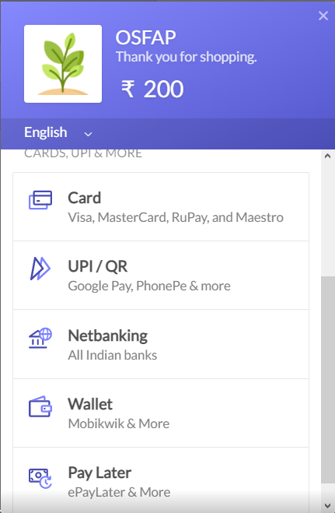

CMRCET 15 B.Tech (CSE)

OSFAP

**CHAPTER 6**

RESULTS AND DISCUSSION

The website we developed contains a home page, login page and a registration page. A user can access the website either as a customer or a vendor. After signing up / logging in, the user can visit the shop and add items to the shop or add items to their cart. A customer can further proceed to the checkout and complete the payment to the vendor. Various payment methods have been made available to the customer. On payment, the vendor receives the order and the item can be delivered without using any third party delivery system.

OSFAP can be further improved by adding a few features in the future. They are -

* Order Tracking
* Cancellation
* Returns and Replacements
* Two-step Authentication
* Returns and Refunds

CMRCET 16 B.Tech (CSE)

OSFAP

**CHAPTER 7**

SUMMARY AND CONCLUSION

OSFAP is an online nursery that enables customers and vendors to buy or sell plants. This website includes useful information about the plants with images. It also allows customers to purchase rare plants.

Our website is user-friendly and caters for all plants. It provides various secured payment methods and there is no involvement of third party delivery. A review section is provided which helps customers to make decisions.

Our website can be further improved in the future by adding features like cancellation, returns/replacements and online tracking. Using this website we get one step closer towards building a sustainable, eco-friendly environment.

CMRCET 17 B.Tech (CSE)

OSFAP

**CHAPTER 8**

REFERENCES

* [http://www.theblogstarter.com/wordpress/?t202id=91264&c1=bingexactfreebegexp and&t202kw=how%20to%20develop%20a%20website%20using%20wordpress&msclkid=01a0bb99fd171bd7a0e0da04ed663bac](http://www.theblogstarter.com/wordpress/?t202id=91264&c1=bingexactfreebegexpand&t202kw=how%20to%20develop%20a%20website%20using%20wordpress&msclkid=01a0bb99fd171bd7a0e0da04ed663bac)
* [https://bubble.io/landing-page-webapp2?msclkid=130c92eca0fc120db41af371b08 d74f7&utm_source=bing&utm_medium=cpc&utm_campaign=Web-App-Alpha&utm_term=web%20development&utm_content=Web%20app](https://bubble.io/landing-page-webapp2?msclkid=130c92eca0fc120db41af371b08d74f7&utm_source=bing&utm_medium=cpc&utm_campaign=Web-App-Alpha&utm_term=web%20development&utm_content=Web%20app)
* <https://websitesetup.org/>
* <https://www.elearningfreak.com/?msclkid=d3f30fe32da31a5869426e7e3cda6130>
* <https://www.gardenguides.com/85767-types-plant-seeds.html>
* <https://healthywaymag.com/diet-and-nutrition/types-of-seeds>
* <https://hackr.io/tutorials/learn-mongodb>
* <https://coursesity.com/free-tutorials-learn/mongodb>
* <https://reactjs.org/docs/getting-started.html>
* <https://www.freecodecamp.org/news/search/?query=react>
* <https://gitconnected.com/learn/node-js/node-dev-guide-5270d6>
* <https://www.probytes.net/blog/how-to-add-payment-method-on-website/>
* https://www.jotform.com/blog/how-to-set-up-online-payments-for-my-website/

CMRCET 18 B.Tech (CSE)